

BCS2203 WEB APPLICATION DEVELOPMENT
SEMESTER 1 SESSION 2014/2015

< MINI PROJECT TITLE: MULTIPLAYER HANGMAN GAME >

PREPARED FOR:
QIN HONGWU

PREPARED BY:
MICHAEL LING CHEE SIANG CA12082
NG KE HUEY CB12098
NUR SYUHAIDAH BINTI ISMAIL CB13006
MAHDI HISHAMUDDIN BIN ABDUL AZIZ CB13009

CONTENT
NO. | DESCRIPTION | PAGE NO.
1 | INTRODUCTION | 1
2 | WEB SITE DESIGN / SYSTEM FLOW | 2 - 13
3 | DATABSE DESIGN | 14 - 15
4 | IMPLEMENTATION/TECHNICAL DETAILS | 16 - 18
5 | REFERENCE | 19

INTRODUCTION

The title of our mini project is ‘Multiplayer Hangman Game’. The features of this project will be an adoption of features from normal hangman game. In this game, player must reveal the hidden word before running out of chance. Each time player makes a wrong guess, the chances will be decreased by one. As ‘hangman’ has 6 different body parts (to-be-hanged), so total chances of 6 will be given to player when player clicks to start new game. Every correct guess is an addition of 20% while any wrong guesses will be a deduction of 10%.
To make this game more interesting, a multiplayer system has been developed. Player is not allowed to play this game unless he/she was challenged by other players. Every player can challenge other players except himself. To send a challenge, player has to select other players’ username and assign a word/phrase either from system database or own. There is no limit for number of challenges to be accepted by player.
At the end of this game, each player’s score will be recorded into database system, and then displayed to players together with other players’ scores.
WEB SITE DESIGN / SYSTEM FLOW
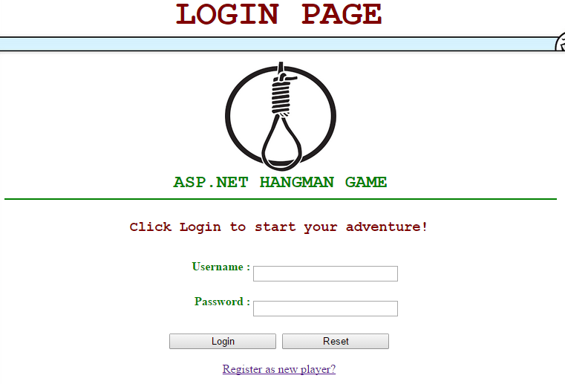
Main Login Page

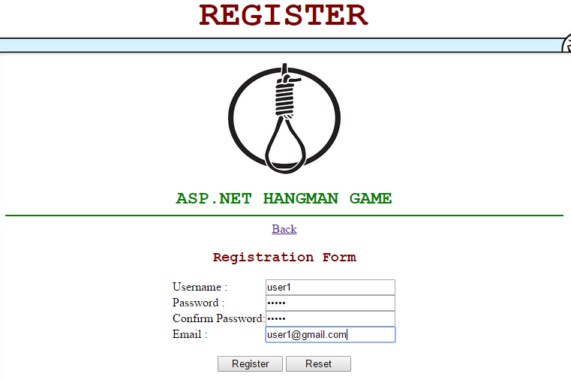
Registration Page (i.e. user1)

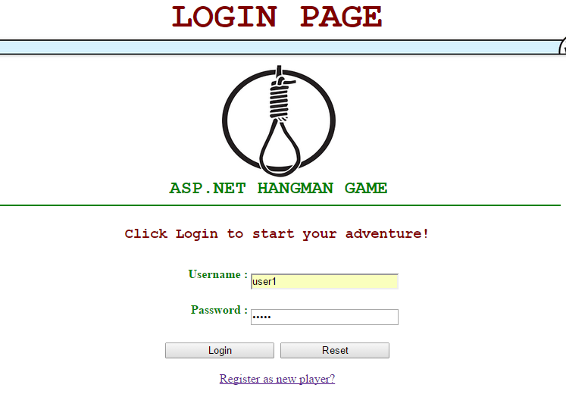
Login after registered as player (i.e. user1)

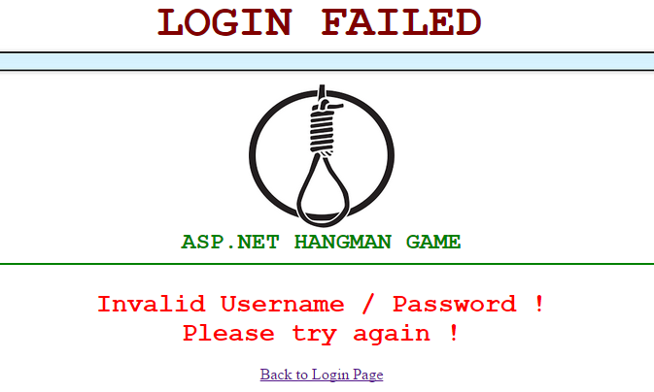
Display error message if user entered incorrect username or password

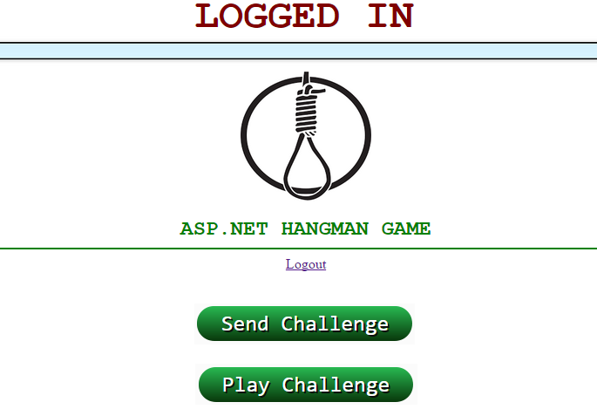
Display main page after successful login

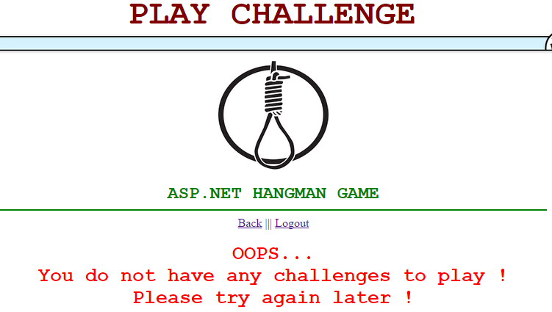
Display message after player clicked on “Play Challenge”
as no players challenged player (i.e. user1)
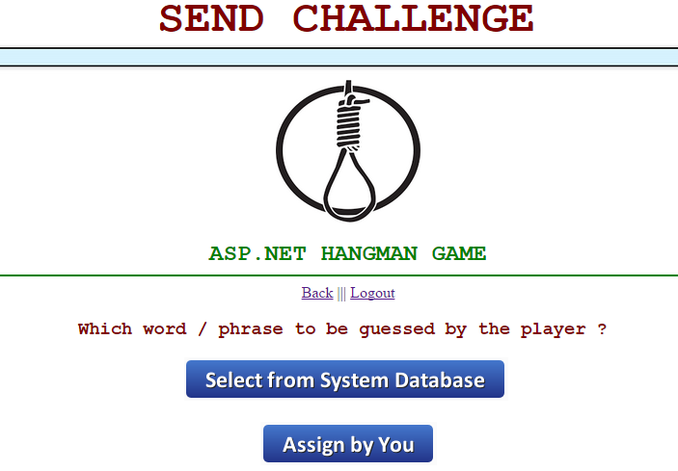
display options after player (i.e. user2) clicked on “Send Challenge”

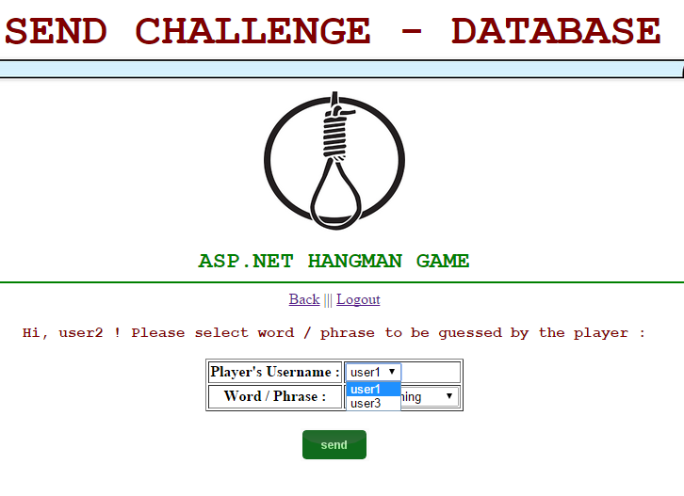
Display page after player (i.e. user2) clicked on “Select from System Database”

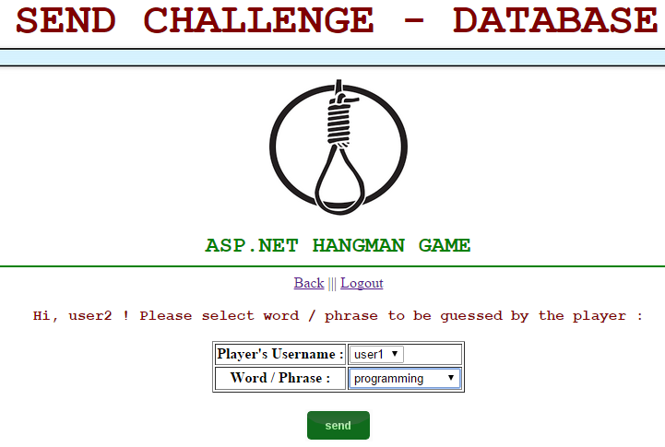
i.e. user2 select user1 to challenge, with a word from database
(i.e. programming)

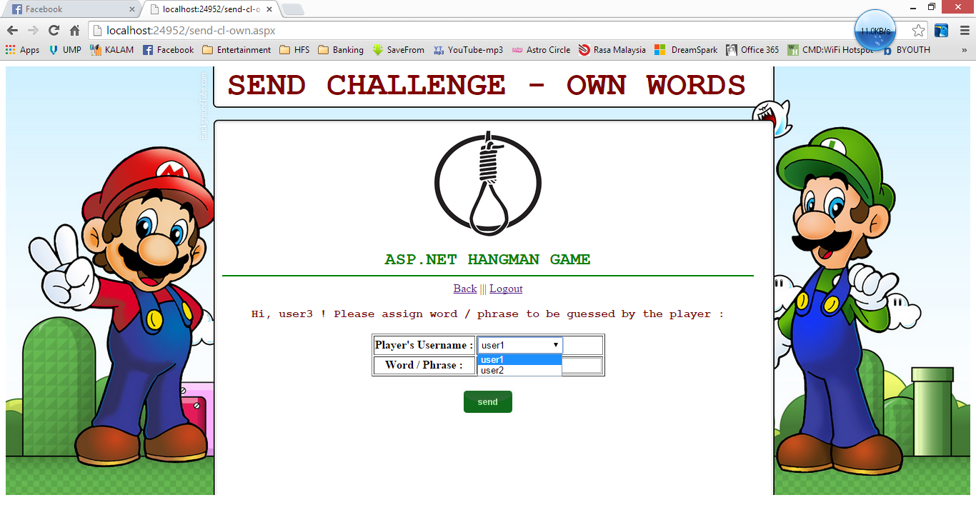
Display page after player (i.e. user3) clicked on “Assign by You”
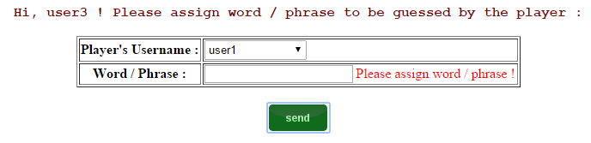
Error message if player did not enter word/phrase before clicking “Send”

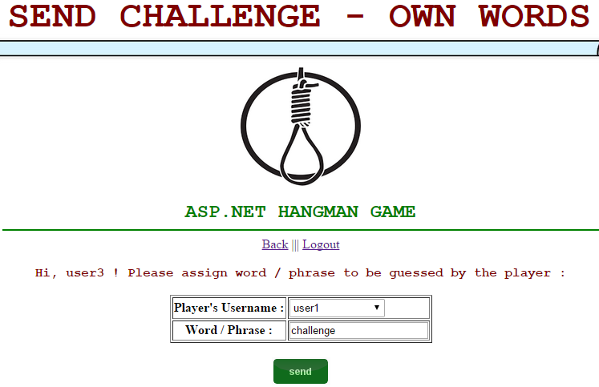
i.e. user3 select user1 to challenge, with his own word/phrase
(i.e. challenge)

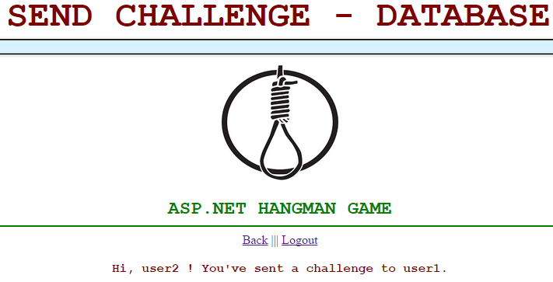
Display notification message after player (i.e. user2 / user3) clicked on “send”
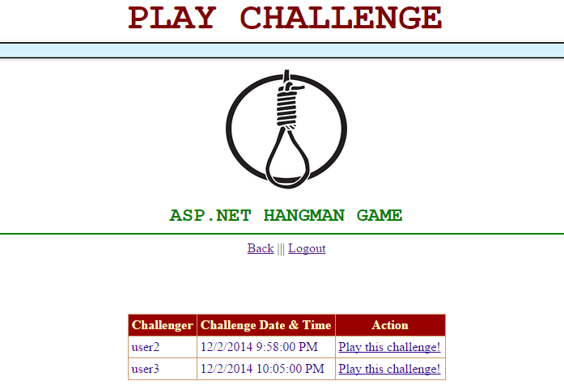

Display lists of challenges when player (i.e. user1) clicked
on “Play Challenge” after players (i.e. user2 / user3) sent challenge

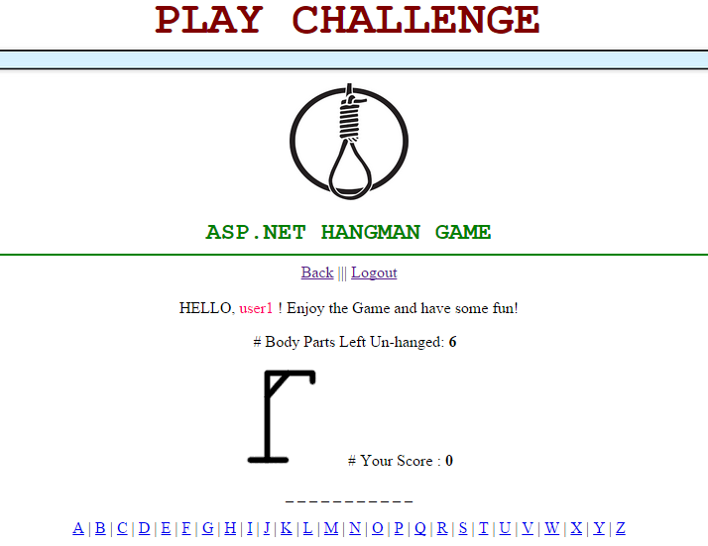

Display main hangman page after player (i.e. user1)
clicked on Play this challenge! for challenge #1(i.e. from user2)
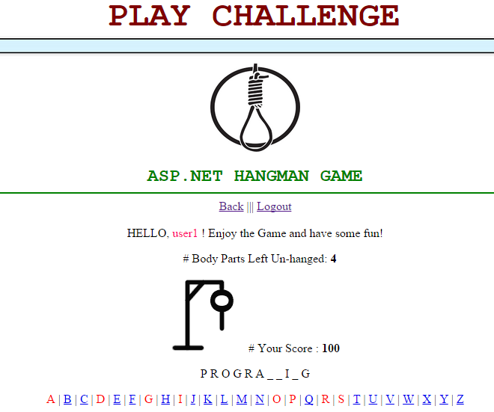

Player (i.e. user1) is playing the challenge (i.e. from user2)

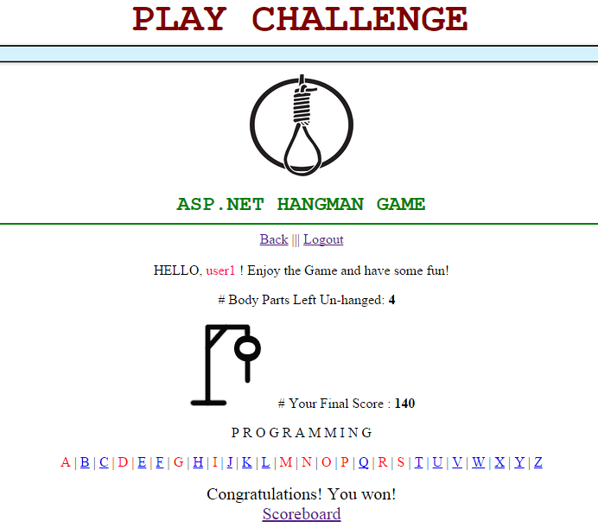
Player (i.e. user1) has finished playing the challenge
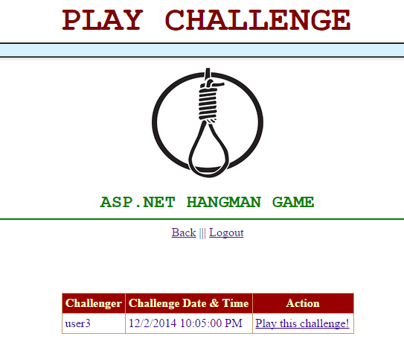

Display lists of challenges when player (i.e. user1) clicked
on “Back” after completing challege from other player (i.e. user2)

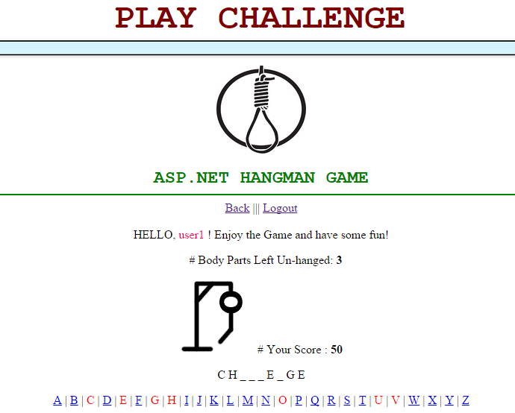

Player (i.e. user1) is playing the challenge (i.e. from user3)
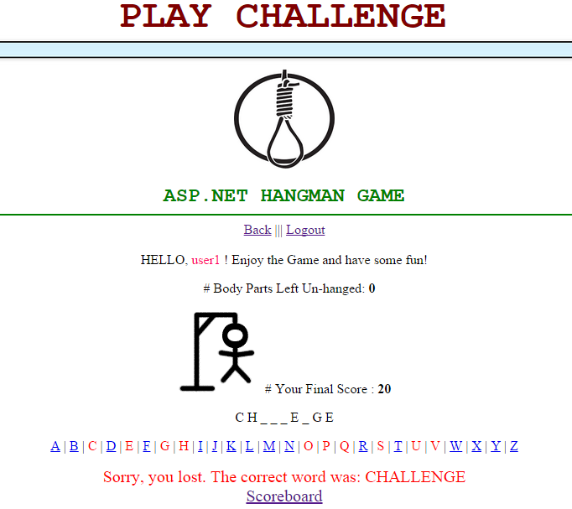

Player (i.e. user1) has finished playing the challenge
**display correct answer after 6 trials

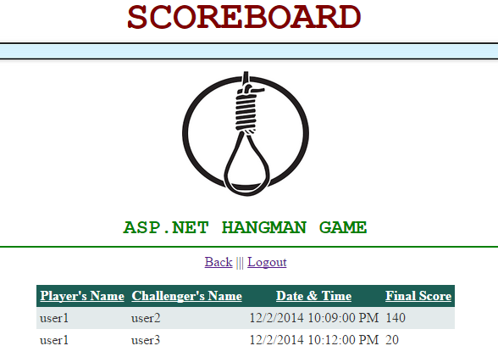
Display scoreboard after player (i.e. user1) clicked
on Scoreboard
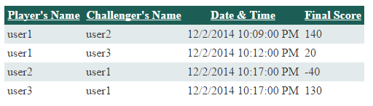

Before sorting by scores

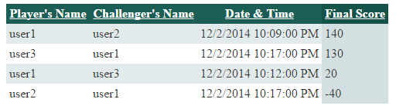

After sorting by scores (highest-lowest)

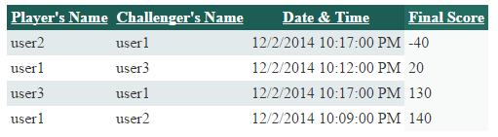

After sorting by scores (lowest- highest)

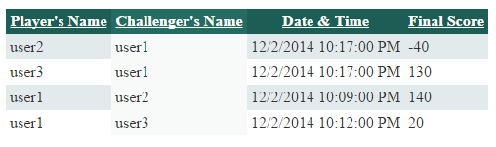
After sorting by Challenger’s Name
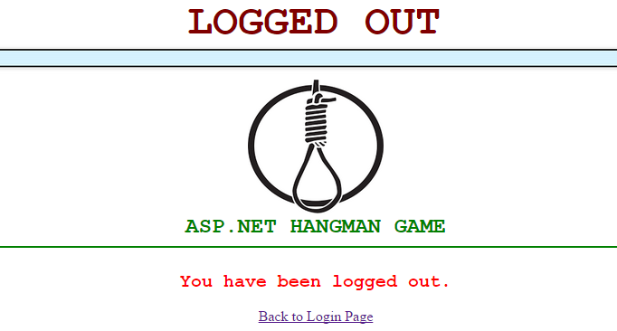
Player (i.e. user1) has logged out from system after clicking
on Logout
DATABSE DESIGN
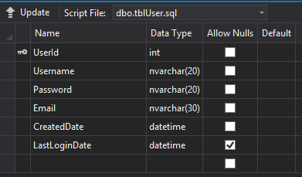

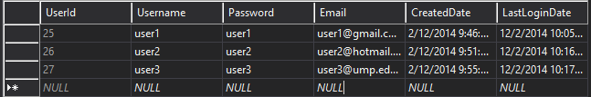
tblUser

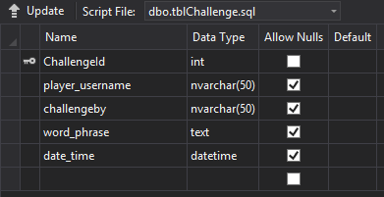

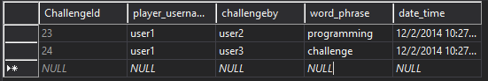
tblChallenge

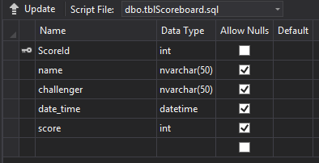

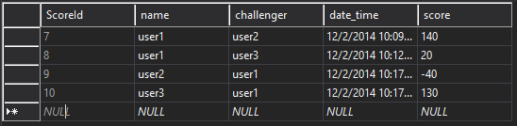
tblScoreboard
IMPLEMENTATION/TECHNICAL DETAILS

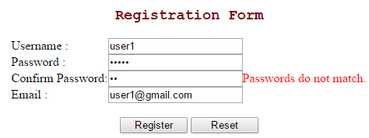
Compare: Value of Password and Confrm Password

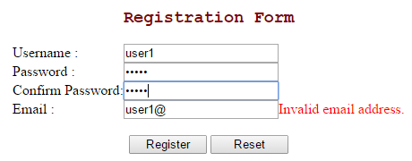
Regular Expression: Validate the email address that user entered is in the correct format

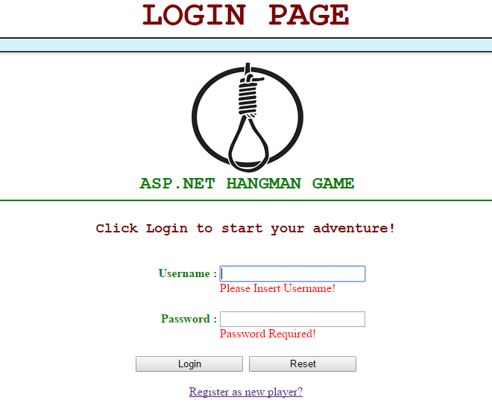
Required Field: Make sure user entered Username and Password to login
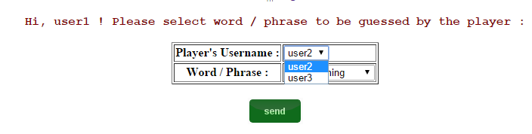
To make sure that user cannot send challenge to himself, data source of the dropdown list of Username has to be configured as below.
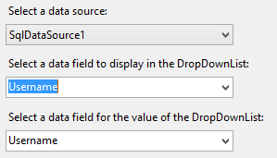
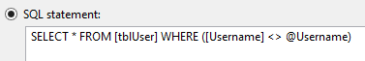

when user clicks Send button to send challenge, the data will be inserted to database (tblChallenge)as shown below.

lblDateTime.Text = DateTime.Now.ToString("dd-MM-yyyy h:mmtt")
SqlDataSource1.InsertCommand = "insert into tblChallenge (player_username, challengeby, word_phrase, date_time) values('" & Session("player") & "', '" & Session("name") & "', '" & Session("word") & "', '" & lblDateTime.Text & "')"
SqlDataSource1.Insert()

To check if the user has any challenges to play, data from tblChallenge will be retrieved as shown below. If yes, a Grid View will be displayed instead of an error message.
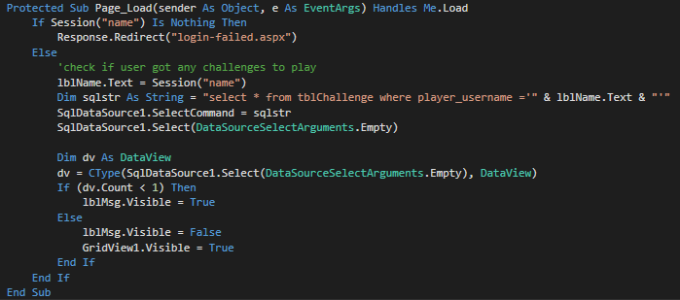
After user selects one of the challenges displayed in GridView1 (Challenge List),the Id No. of the specific challenge selected will be passed to next page. (play-cl.aspx)
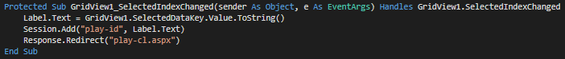

and the respective Id. No. will be used to identify the word or phrase to be guessed by the user, which is retrieved from the table tblChallenge.
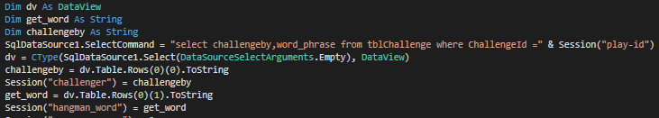

Then user will start playing the hangman game until they run out of chance or have won the game within 6 trials.
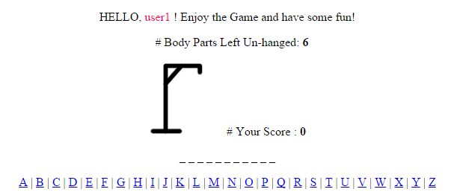

Once user completed the game, win or lose, the challlenge is considered done.Hence, the record will be removed from tblChallenge, and the score will be inserted into tblScoreboard for the purpose of display.
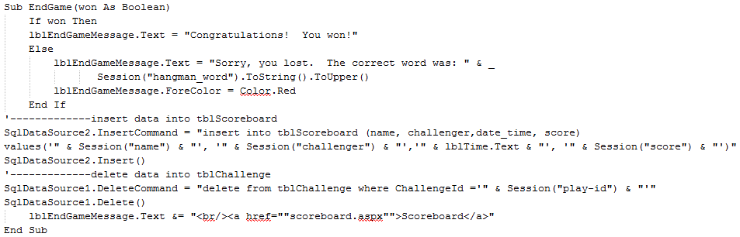
REFERENCE

- http://www.w3schools.com/aspnet/
- http://www.aspsnippets.com/
- http://www.asp.net/
- http://www.tutorialspoint.com/asp.net/
- http://www.java2s.com/Tutorial/ASP.NET/CatalogASP.NET.htm

